NATIONAL NEWSLETTER – MAY 2019
- ANNUAL GENERAL MEETING - NATIONAL BODY
- PAN-AFRICAN MEET 2019
- KZN SECTION CENTENARY – JULY CAMP

AAC TO HOST 12TH INTERNATIONAL CLIMBERS’ MEET
- PLANNED EXPEDITION TO THE PAMIR MOUNTAINS, CENTRAL ASIA
- UIAA GLOBAL YOUTH SUMMIT EVENT TO BE HELD IN IRAN
- UIAA
- FACEBOOK AND WEB PAGES
- ANY NEWSWORTHY ITEMS
- SNIPPETS

- ANNUAL GENERAL MEETING - NATIONAL BODY
After most of the Sections have held their respective AGMs, it is the turn of the National body. The AGM of the Mountain Club of South Africa will be held in the Cape Town Section’s Clubhouse on Saturday 11 May at 0830.
Please note that the actual AGM is a short, formal meeting where the only real business is the election of the Executive - President, Secretary, Treasurer. The following members have been nominated for these positions:
- President – Greg Moseley
- Secretary – Jenny Paterson
- Treasurer – Lester Coelen
After this short, formal meeting, the National Committee of the MCSA will meet. The National Committee consists of the chairs of all the Sections (or their designated alternates). The meeting generally lasts several hours and is not open to all club members. However, the Executive and the National Committee are pleased to accept written contributions from any member with a point to raise. Please note that such submissions should be of national interest and not purely sectional.
- PAN-AFRICAN MEET 2019
After last year’s successful inaugural event in Uganda, the Mountain Club of Malawi is hosting this year’s version of the Pan-African meet on Mulanje in August/September. The initial details are as follows:
- Arrival in Blantyre on Friday 30th August
- Start hiking on Mulanje Mountain on Saturday 31st August
- Descend from mountain and return to Blantyre on Saturday 7th September
From Sunday 8th September group members can fly home or continue their holiday in Malawi e.g. visit the lake, game parks etc.
This meet, as last year’s, is in conjunction with the Confederation of African Mountain Clubs, - formed as a result of an MCSA initiative.
- KZN SECTION CENTENARY – JULY CAMP
This year marks the Centenary of the KZN Section of the MCSA so their annual July Camp in the Drakensberg will be very special!
They have changed tactics slightly, while keeping the spirit of July Camp the same, if not even better this year on account of the Centenary!
This July Camp has been shortened to ten days and also, to accommodate many requests, we are starting the July Camp on the Friday, thus giving Campers two weekends with a week in between. The dates are Friday 28th June to Sunday 7th July, 2019. It almost could now be called the June Camp, but it is so early to tie in with the Provincial school holidays.
The Camp will be held at Cobham in the Southern Berg, in the official Camp Site so that access to the Base Camp will be easy for ALL ages. You just drive up to your selected site, unpack your car, and promptly drive it to the demarcated Parking Place, return to your selected spot, put up your tent and ENJOY YORSELF.
Further details are available from the KZN Section

AAC TO HOST 12TH INTERNATIONAL CLIMBERS’ MEET
The American Alpine Club is hosting its 12th annual International Climbers’ Meet (ICM), to be held the week of 13-19 October, 2019 in Yosemite Valley. The event will include three days of education programming, host climbers available for guidance, and, per usual, an international cast of characters that will be crushing Yosemite.
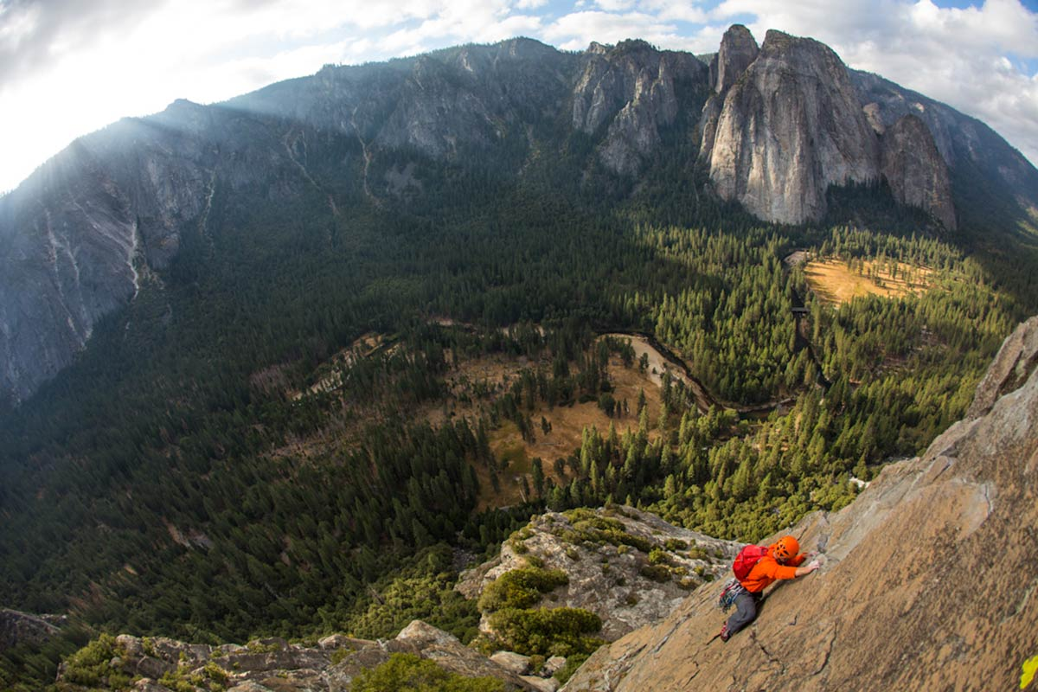
Applicants should have intermediate or advanced level experience with:
- Placement and removal of protection
- Multi-pitch rope management
- At least two years of technical rock climbing
- The ability to follow sustained 5.8 granite
Discounted fee for International participants:
Earlybird fee until 31 July is $495 USD per person.** Beginning 1 August, the fee will be $545 ** Your fee includes:
- Seven nights and six days of camping at secluded Yellow Pines camp ground.
- Three gourmet catered meals per day from Sierra Gourmet catering.
- Six days of climbing in spectacular Yosemite Valley.
- Three optional instructional days hosted by AMGA certified guides and instructor.
- Pre-dinner mini-clinics on a range of technical topics.
- One day of stewardship for Yosemite National Park.
- Nightly campfire for storytelling, socializing, and general carousing.
- Partner with other participants or experienced host climbers.
Participants provide their own transportation to Yosemite Valley, California. A full roster will be sent to all participants for coordinating ride sharing.
International applicants: You will receive notification of the status of your acceptance by 31 May
- PLANNED EXPEDITION TO THE PAMIR MOUNTAINS, CENTRAL ASIA
Please note that this trip has been postponed until 2020. If you are interested in participating, please contact Dobek Pater on dobek@africaanalysis.co.za or tel. 083 306 2306.
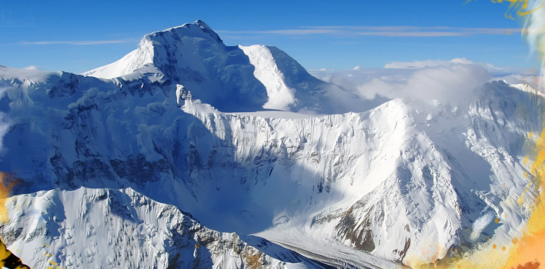
Ismoil Somoni Peak (Pik Komunizma)
6. UIAA GLOBAL YOUTH SUMMIT EVENT TO BE HELD IN IRAN
Dates: 20 July to 1 August, 2019
Mountains: Alam-Kuh and Damavand
Place: Tehran & Mazandaran Province, Iran
Accommodation: 2 nights in D/hotel, 1 night in Polour lodge, 1 night in Vandarbon lodge, 3 nights in Atour eco-camp in Alam-Kuh, 2 nights in Atour eco-camp in Damavand, 1 night in a villa. The rooms in lodges have bunkbeds and will be shared among mountaineers. The tents in both eco-camps will be shared by two or three people.
Food: all meals are included, warm freshly cooked meals will be served in mountain and lunch box is prepared for summit days. There are warm and cold beverages are available in the eco-camp which is also part of event services.
Guide: for every five mountaineers one guide will accompany the group. All the guides are members of Iran national team and instructors of mountaineering as well.
Participants: Mountaineers of 15 to 30 years old are welcomed to participate in this programme. The programme can be customized for families who prefer to accompany their children as well. ANY PARTICIPANT UNDER THE AGE OF 18 MUST BE ACCOMPANIED BY A GUARDIAN OR APPROVED MOUNTAIN GUIDE
Equipment: Trekking shoes, socks, sleeping bag, jacket and pants (Gore-Tex or Synthetic rain/snow/wind), backpack (plus a small attacking backpack), trekking stick, gloves (polar wool), hat (warm pile/wool), hat (should cover ears), balaclava, baseball cap, scarf, sun glasses, sunscreen cream (SPF 40 above), personal first-aid kit, water bottles, headscarf, camera, headlamp, Swiss army knife, travel clothes.
Insurance: Participants are advised to get themselves insurance for accident, rescue, and third-party liability which is valid for participating in the programme of climbing and trekking. It is not compulsory on our part. However, personal travel insurance is mandatory and should be obtained by the traveller.
Visas: The organizer will arrange for visa, providing visa code for all participants (and families) which would ease the process of visa issuance greatly. However, considering that the process of Iran visa is different for each country. For South Africa it is a long process, and includes specific medical information.
COSTS: there are three different packages:
- Booking before 10 June 2019:
Alam-Kuh only = €350;
Damavand only = €330;
Full package €670.
- After 10 June 2019:
Alam-Kuh only €380;
Damavand only = €350;
Full package €720.
SPONSORSHIP: Interested MCSA Youth Members can apply for some funding from the Centenary Journal Youth Fund. For further information and an application form and information about sponsorship, please contact: jennyapaterson@gmail.com
- UIAA
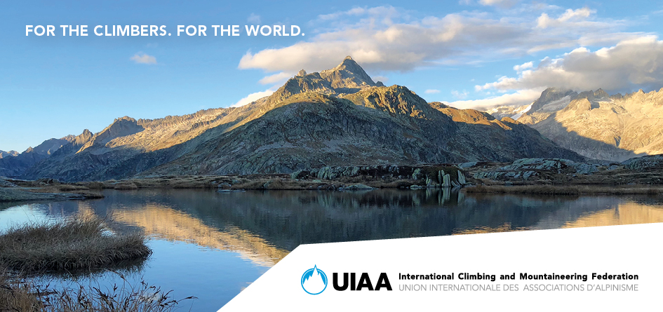
7.1 GENERAL
The UIAA continues to develop its services for members and will be improving its web page to offer federations the opportunity to exchange more details about climbing and mountaineering in their own countries. A Donate page will also be available to members who wish to showcase initiatives and causes they are supporting. Both projects will be rolled out during the first quarter of 2019.
Members are therefore reminded of many existing resources, and some new ones, provided by the UIAA. This includes the newly-launched online rock and ice climbing festival search tool (see below), a UIAA platform which offers federations the chance to promote events in their region. The UIAA Safety Standards, high-altitude medical advice, training standards and mountain protection projects continue to evolve, providing expertise at the benefit of members and entire climbing and mountaineering community. Expertise which comes directly from the valuable volunteer efforts of UIAA Commission members, nominated by UIAA member federations worldwide. Members are encouraged to go to the UIAA web site http://www.theuiaa.org/ to find out more about the UIAA‘s important activities.

7.2 UIAA MOUNTAIN PROTECTION AWARD

The UIAA Mountain Protection Award (MPA) was created in 2013. During its six years of existence, the annual UIAA Mountain Protection Award (MPA) has made a tangible difference to mountain lives, communities and the environment. It has enabled people to raise finances to build key infrastructures, conduct vital research and fulfil pending goals; it has provided an international showcase and communication platform for projects to raise awareness and exchange ideas and initiatives. Not only has it supported local communities, it has fostered its own global community. The Award celebrates innovation and a desire to make a difference.
The award consists of a platform where selected mountain protection projects are showcased and promoted, as well as a prize which is awarded to one winning project every year. The UIAA MPA projects platform is open to all UIAA member federations, as well as other associations or institutions whose activities are directly related to mountaineering and mountain-based sports. To apply for the UIAA MPA, projects must correspond to at least one of the following categories:
- Conservation of biodiversity – including flora and fauna
- Sustainable resource management, such as energy or water
- Sustainable waste management and disposal
- Adaptation to/mitigation of effects of climate change
- Protection of the environment through culture and education
Visit https://www.theuiaa.org/mountain-protection-award/ for more information.

7.3 BMC LAUNCHES HILLS TO OCEANS CAMPAIGN
Around 80% of all the debris in our oceans and seas originally comes from inland, according to estimates, so the British Mountaineering Council (BMC) is asking all its members and the wider public to help reduce this amount by joining an existing litter pick or by organising their own.
This is a very worthwhile idea and one that we could well follow in this country. We could well follow the BMC and organise events throughout South Africa. Whether you simply take a bag and a litter picker with you next time you go to your local crag or wish to arrange a clean-up event of the entire length of the Magaliesberg for example, with your friends, family or local MCSA Section. Details of how to arrange a successful event can be found in a resource pack along with a template risk assessment at https://www.theuiaa.org/mountaineering/bmclauncheshillstoocean/

7.4 UIAA AND DAV COLLABORATE ON SAFETY VIDEO PROJECT
The UIAA and the German Alpine Club (DAV) have teamed up to produce a series of ten videos designed to help improve climber’s belay technique. Originally produced by the DAV, the videos have recently been translated into English following collaboration with the UIAA Safety Commission and UIAA Training Panel.
The principal focus is different belaying techniques and the instructor in the video is Christoph Hummel, a member of both the DAV safety research department and the UIAA Safety Commission, who spearheaded the initiative.
“This project is the fruit of excellent collaboration between the UIAA and one of our largest member associations,” explains UIAA Director of Operations Nils Glatthard. “Making these videos available in English and through the UIAA’s international network will help increase awareness and the important messages about safety covered in these features. Furthermore, the project has helped further discussions between a number of Commissions in the UIAA and the DAV about further collaboration.”
Visit https://www.theuiaa.org/mountaineering/uiaa-and-dav-collaborate-on-safety-video-project/ for more information.

7.5 TRAVELLER’S DIARRHOEA – PREVENTION AND TREATMENT IN THE MOUNTAINS
The issue of traveller’s diarrhoea is a critical one for anybody wishing to take part in expedition mountaineering or trekking. The risks from diarrhoea are proven to be much greater at altitude than they are at sea-level. Studies have indicated that the loss of body water as well as electrolytes significantly impairs both physical and mental capacity. This in turn, greatly increases the risk of Acute Mountain Sickness (AMS), thrombosis, frostbite and various other altitude related conditions.
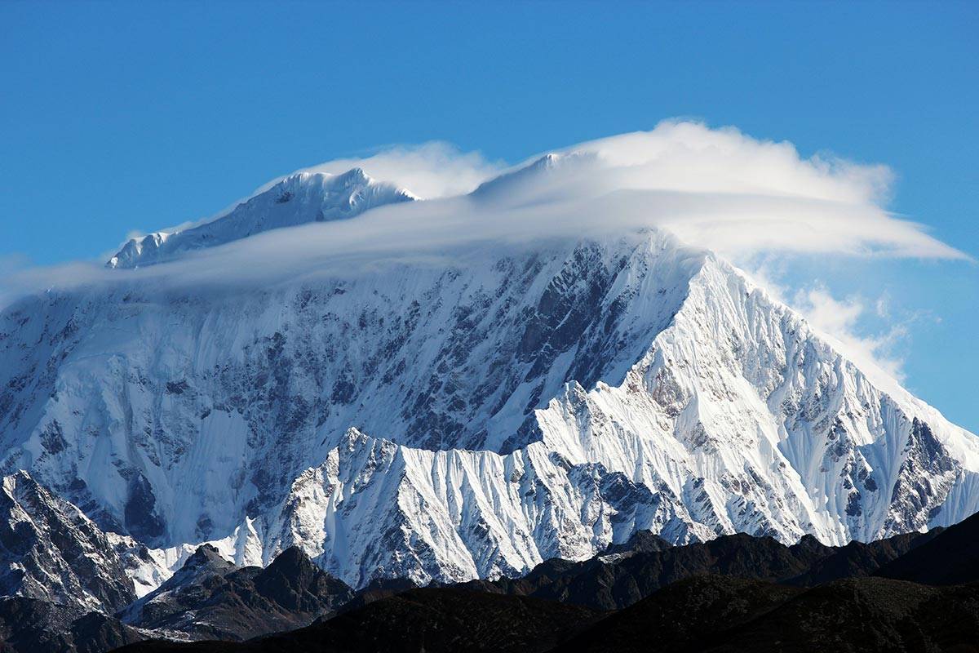
The UIAA has produced a dedicated paper on the subject. It was published in 2008 by T. Küpper, V. Schoeffl & J. Milledge and is available to download at: https://www.theuiaa.org/mountaineering/travellers-diarrhoea-prevention-and-treatment-in-the-mountains/
The paper outlines the various steps that trekkers and mountaineers can undertake, not only to minimise the risks, but also practical treatment options should they indeed fall ill

7.6 UIAA TRAINING SERVICES CONTINUE TO FLOURISH
One of the UIAA’s core services and direct benefits it offers member associations comes courtesy of its training qualifications and programmes which are both supported by a rich library of practical information.
At October 2018’s UIAA General Assembly, details on the impressive collaboration between the UIAA, The Petzl Foundation and members worldwide in translating versions of the UIAA Summer Skills Alpine Handbook was presented. Since the GA, work has continued to evolve at an impressive rate.
The Handbook, available internationally as a digital download (price as of March 2019, 3.99 GBP/4.63 EUR/5.22 USD), is regularly updated with anyone purchasing the publication able to access new chapters and information. A section on Trad climbing has recently been completed, one on canyoning is in progress. Anyone interested in purchasing the Handbook is encouraged to view the dedicated UIAA Skills series which features extracts from the guide.
The Handbook is designed to help mountain leaders and climbers develop their skills, whether reinforcing lessons learned and not yet fully assimilated or to increase technical knowledge and reduce the risks inherent to the activity. The advice is wide-ranging covering subjects as diverse as the weather, rescue operations, adapting to the environment, teamwork and equipment advice. It covers alpine hiking, climbing and alpinism.
The Handbook complements the range of training accreditations that the UIAA provides for members to demonstrate adherence to recommended practice for teaching personal skills, leaders and instructors/coaches. This is now an integrated system that will empower instructors qualified by an accredited federation to deliver personal skills training to novice and intermediate hikers, climbers, mountaineers and canyoners according to their qualification(s). After completing a UIAA accredited personal skills training course, students will be able to download a certificate of attendance bearing the UIAA logo, showing that the course fulfilled the UIAA requirements for provider, syllabus and contact hours. This service can also help federations to assist countries that have not yet developed their own federation. These services will be delivered through the federations, who can add their own branding and charging for services if they choose.
8. FACEBOOK AND WEB PAGES
8.1 National: abbreviated link for the national MCSA Facebook page: www.facebook.com/MCSA125/
8.2 Links for all the sections’ web pages are on the MCSA national webpage.
9. NEWSWORTHY ITEMS
Please send any newsworthy items for inclusion in MCSA National News Editor, Ineke Moseley at: inekemos@zsd.co.za
10. SNIPPETS
Much of the news on internet sites is more applicable to the northern hemisphere and particularly Himalayan mountaineering. The selection of news is completely arbitrary. I do hope that some of it is interesting to members.

10.1 YOSEMITE CAMP 4 CAMPGROUND BOOKING CHANGES

Camp 4, the storied Yosemite climber campground, will be testing out an online lottery-based application system in 2019. So keep this in mind if you are planning a trip to Yosemite. https://www.climbing.com/news/camp-4-campground-switching-to-online-lottery-system-for-sites/
10.2 EVEREST: STILL DRAWING LARGE NUMBERS OF CLIMBERS
The 364 climbers on the Tibetan side of the mountain is just about exactly half the number that the South Side in Nepal will see. There should be roughly 725 climbers in South Side Base Camp this year, which brings the grand total to 1089. https://adventureblog.net/2019/04/himalaya-spring-2019-everest-north-side-numbers-announced.html

10.3 NEPAL TO REMEASURE THE HEIGHT OF EVEREST THIS YEAR
Nepal is looking to put an end to the ongoing dispute over the exact height of Mt. Everest once and for all. This spring a team of surveyors will travel to the mountain to remeasure the height of its summit in an effort to determine its elevation as accurately as possible. The expedition has been in the works for several years now, but will finally come to fruition over the next month or so, with the results to be released in January of 2020. https://adventureblog.net/2019/04/nepal-to-remeasure-the-height-of-everest-this-year.html

10.4 THE NORTH POLE SEASON HAS BEEN CANCELLED
Barneo Ice Camp in the Arctic Ocean serves as the temporary base of operations for travellers, researchers, and adventurers heading to the Arctic, most notably last-degree skiers on their way to the North Pole. But this year, a political stand-off between Russia and the Ukraine grounded flights that were designated to deliver people, supplies, and gear heading to Barneo, delaying the start of the season and putting it in complete jeopardy. The season has been cancelled altogether due to logistical challenges and a rapidly closing window. https://adventureblog.net/2019/04/breaking-news-the-north-pole-season-has-been-cancalled.html
QUOTABLE QUOTES:
“I don’t know who was the conqueror or who was conquered. I do recall that El Cap seemed to be in much better condition than I was.” Warren Harding, after his first ascent of the Nose in 1958.

