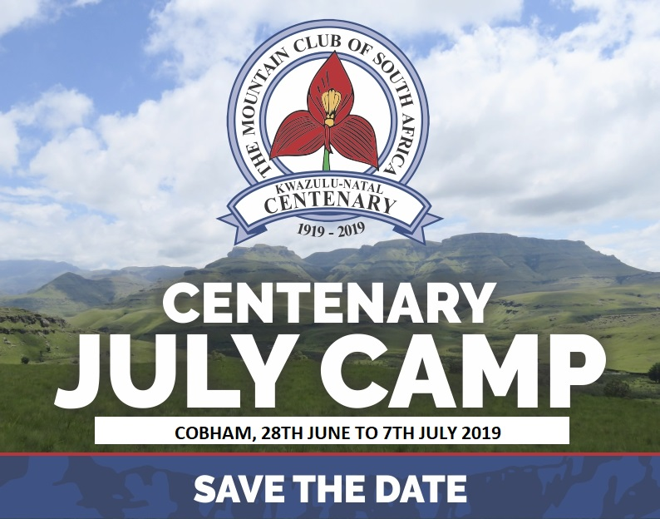

THE CENTENARY JULY CAMP, 2019, WILL BE AT COBHAM

Friday 28th June to Sunday 7 July 2019

We had planned to get the Centenary July Camp brochure out really early, say, at the beginning of the year, but due to all manner of reasons we have not been able to do so.

We are now aiming to have it out by Easter.

But in the meantime ....... THERE WILL BE A VERY SPECIAL JULY CAMP THIS YEAR - THE CENTENARY!

We have changed our tactics slightly, while keeping the spirit of July Camp the same, if not even better this year on account of the Centenary!

First, we have shortened the July Camp to ten days because the second week was not paying its way. Second, to accommodate many requests, we are starting the July Camp on the Friday, thus giving Campers two weekends with a week in between. The dates are Friday 28th June to Sunday 7th July, 2019. It almost could now be called the June Camp, but it is so early to tie in with the Provincial school holidays. WE would like you to share the entire Camp with us, but if you can manage only a few days, that is easy to arrange.

The Camp will be held at Cobham in the Southern Berg, in the official Camp Site so that access to the Base Camp will be easy for ALL ages. You just drive up to your selected site, unpack your car, and promptly drive it to the demarcated Parking Place, return to your selected spot, put up your tent and ENJOY YOURSELF.

To celebrate the Centenary we will be starting with Festive Friday, a simple supper affair. Just sherry and the Mountain Club toast before an ordinary July Camp supper (we thought that people might be too tired for a function that night, having driven all the way there and then putting up their tents).

The main Centenary Celebration with be the Centenary Luncheon at 12:30 for 13:00 on Saturday 29th June in a marquee with tables and chairs – a first for July Camp!!!! The caterer is a specialised outdoor caterer and the menu for the 3-course meal is mouth watering. The lunch will be offered at cost, R220.

For those who prefer not to have the Lunch, it will be business as usual, with all the lunch ingredients being put out after breakfast for Campers to make their own pack lunches. Since the men who usually do all the cooking and preparing of meals will be our invited guests at the Centenary Lunch – there will be no prepared lunch served in Base Camp that day.

Please spread the word to your wider group of like-minded friends, we really would love to have you ALL with us to help celebrate the July Camp CENTENARY!

Looking forward to seeing YOU and your mountain-minded friends at the CENTENARY JULY CAMP at Cobham
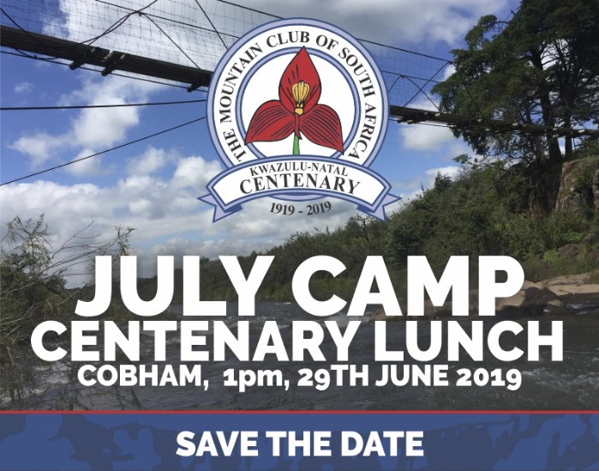
Centenary Celebrations
These will begin with the Festive Friday evening ‘happy hour” with our own drinks and snacks. We hope that newcomers will tell us what they would like to do so that we can try to meet their expectations.
As the gong goes we will have a sherry and the traditional Mountain Club toast ,
“ONCE MORE, ONCE LESS’.
After dinner we gather again with much laughter as we invite the old timers to tell of their reminiscenses and the “old climbers, bold climbers’ of the Camps gone by.
We hope to have some good singers as we used to do. There are still some song books for sale at R50, these are real JULY CAMP memorabilia.
Centenary Lunch
This will be held on Saturday in a large marquee with tables and chairs ! A first for July Camp, at 12:30 for 13:00. There will be a stunning 3 course menu with a special vegetarian offer all produced by an expert outdoor caterer. Luncheon will be a leisurely, unrushed affair. The meal costs R220 per person regardless of age. We hope YOU will join us.
Those who prefer not to participate will be able to make up their own packed lunch from the selection put out after breakfast. This will have been indicated on each booking form.

