NATIONAL NEWSLETTER – NOVEMBER 2018
- JOURNAL 2018
- KAMCHATKA
- UIAA
- FACEBOOK AND WEB PAGES
- SNIPPETS
- ANY NEWSWORTHY ITEMS

1. JOURNAL 2018
Contributions for the 2018 Journal need to be submitted by 31 January 2019. These can be sent to the Editing Team to: jennyapaterson@gmail.com Please refer to the Guidelines and Style Sheet on the national website before you submit any contribution: these can be found on the following link: http://www.mcsa.org.za/home/journal
2. KAMCHATKA, RUSSIA - 7-21 JULY 2019
Ulrike Kiefer led a small group to Kamchatka. Her recent presentation elicited a lot of interest. All members of the group said what an amazing trip it was.
Her Russian contact is thinking of doing a similar trip in June 2019 – a lighter trekking in Kamchatka for 7-21 July 2019: there is no glacier walking, a detour to another valley, an extra volcano climb and included the boat trip: he is offering a €160 early booking discount off the quoted price until the New Year. Also worth mentioning that Aeroflot direct flights for summer 2019 are not available yet so the current flight prices should not be a deterrent.
Go to the web site: https://drive.google.com/open?id=1R6OmRKqkXAdr0MsgUxEOkIpcp70Tb_0JJZ4b2nty9J8
3. UIAA
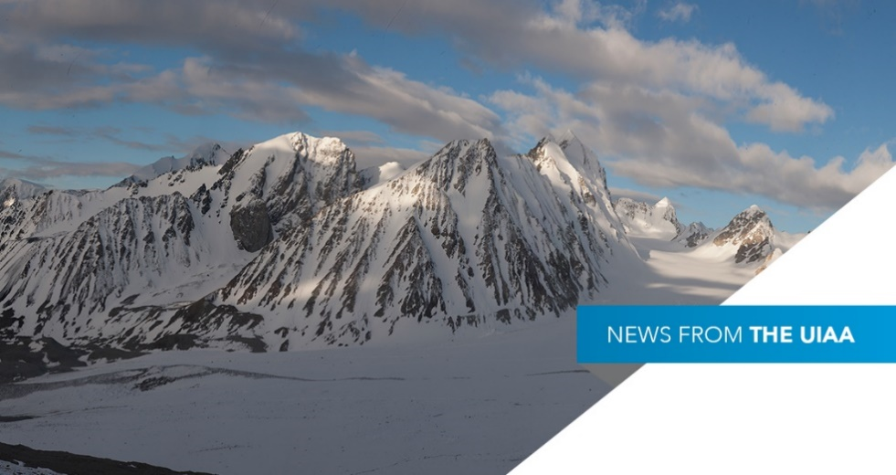
Some selected highlights of recent UIAA activities are provided below. Members are encouraged to go to http://www.theuiaa.org/ to find out more about the UIAA‘s important activities.
3.1 UIAA 2018 GENERAL ASSEMBLY – ULAAN BAATAR
The UIAA 2018 UIAA General Assembly was held in October and was an event expertly hosted by the Mongolian National Climbing Federation (MNCF).
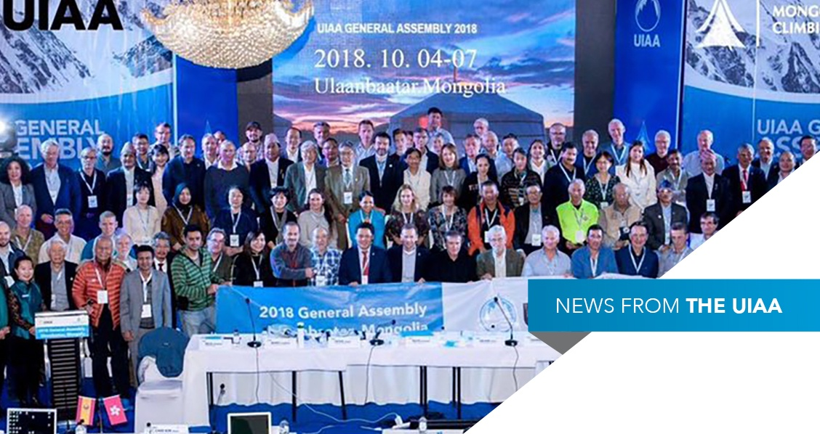
It was indeed a great success in that considerable progress was made in defining the UIAA’s role in the world as the premier international mountaineering organisation. While the 5-year strategic plan is still a work in progress (watch this space) there were other events which were of considerable significance, some of which are reported below. There will be a report on the General Assembly in the December Newsletter.
3.2 UIAA INTERNATIONAL YOUTH ICE CLIMBING CAMP
The French Alpine Federation will be hosting another ice climbing camp in Guillestre, Hautes Alpes, France between 24 February and 02 March 2019. All the ice climbing sites are described on the web site: http://www.ice-fall.com/
Accommodation will be in a ‘gite’ (hostel); 4 people sharing. Breakfasts and dinners are provided and are included in the price.
Participants: Must be between 16 and 26 years old. Participants should lead climb at a minimum of 5b French grade, and should be autonomous for managing belay. The Federation is offering places to maximum of 4 participants per country Federation. Participants younger than 18 years old must be accompanied by an adult Climber/coach, who is able to look after them during this meet.
Equipment: climbing harness, winter alpinism shoes with ice crampons, climbing helmet, belay device and 05 quick draws (UIAA standard/CEN), 2 ice axes (could be rented by staff), one avalanche detector device (could be rented from staff), 05 ice screws, sun glasses & cream, sleeping bag, head torch, winter climbing clothing and toiletry kit, water bottle, any personal medication.
Insurance: Participants should be insured for accident, rescue, third party liability and travel which is valid for participating in the programme of climbing and trekking. A copy of each insurance should be presented to the organisers on arrival.
Meeting point: Blagnac Airport (Toulouse) on Saturday, February the 23 (then travelling the 24 th in minibus with French young participants from Toulouse).
Visas: South Africans need a visa for France, so early application should be made.
Price: 250 EUR per participant, payable on arrival to the organiser. Accommodation, full board, leading and organisational costs included (except picnic of midday).
Deadline (for South African participants): 5 JANUARY 2019 (to allow time for the visa and other formalities)
Photographs of the 2018 Camp can be seen on: https://photos.app.goo.gl/wfxcECOmeFHLH8Bi2
Further information can be obtained from the MCSA Secretary: email secretary@mcsa.org.za or jennyapaterson@gmail.com
3.3 2018 UIAA MOUNTAIN PROTECTION AWARD
At the final gala dinner, the recipients of two prominent international UIAA Awards were announced. Community Action Nepal was revealed as winner of the 2018 UIAA Mountain Protection Award.
Community Action Nepal (CAN) is a charity and NGO/INGO which has been operating in Nepal for over 20 years. It was set up by legendary mountaineer and former UIAA Management Committee member Doug Scott CBE. Scott wanted to give something back to the mountain people of Nepal.
In 2015, CAN’s focus took on a more specific objective. Much of CAN’s own work over two decades was wiped out in a matter of minutes following the devastating earthquake which hit Nepal in April of that year. Consequently, the charity’s strategy was directed towards supporting the recovery of earthquake-affected communities in remote mountain areas. The disaster killed nearly 9,000 people, injured more than 22,000, destroyed entire villages, displaced almost three and a half million individuals and caused over ten billion dollars-worth of infrastructure damage. Century-old buildings, monasteries and temples were destroyed.
Details can be seen on the UIAA web site at - https://www.theuiaa.org/uiaa/community-action-nepal-becomes-sixth-recipient-of-uiaa-mountain-protection-award/
3.4 2018 UIAA ROCK CLIMBING FESTIVAL AWARD
The UIAA Rock Climbing Panel presented the concept of the Award which was launched in 2015 and is dedicated to a different continent each year. The focus in 2018 was South and Central America with three festivals recognised. Given the strong profile of each of the candidates, the Award Panel decided to recognise all three shortlisted projects, splitting the overall prize money.
The Festival de Boulder de Mar del Plata in Argentina was announced as the overall winner with Bolivia’s BLOQUEando handed the development prize. The Capixaba Climbing Festival in Brazil was runner-up. (See web site - https://www.theuiaa.org/mountaineering/prizes-shared-amongst-south-american-candidates/).Click here.
4. FACEBOOK AND WEB PAGES
4.1 National: abbreviated link for the national MCSA Facebook page: www.facebook.com/MCSA125/
4.2 Links for all the sections’ web pages are on the MCSA national webpage.
5. SNIPPETS
5.1 An amusing article about the different types of climbing. https://www.climbing.com/news/real-rock-climber/
Unsent /un-sent/ 1. To have failed so badly on a route you had previously climbed that you negate your redpoint. 2. A humor column.
5.2 New trail in Chile from Puerto Montt to Cape Horn
https://www.bbc.com/news/world-latin-america-45663960
5.3 AFRICAN MOUNTAIN RESEARCH TIMES October 2018
AfroMont is a communication and networking organisation interested in research and policy relating to African mountains.
Afromont aims to highlight experiences from research, field projects and innovation and best practice in sustainable mountain development and climate change adaptation in African countries.
During the October 2018 GLOMOS event, there were many stimulating presentations, statements and discussions, and it was very useful to see how mountain research in Europe, South America and Asia deals with many similar challenges, yet with a variety of solutions. There is a lot that African scientists can learn from meetings like this.
http://www.mountainresearchinitiative.org/en/mri-africa-news/african-mountain-research-times-october-2018
- NEWSWORTHY ITEMS
7.1 MCSA YOUTH PROGRAMME
16 children attended the Outdoor Climbing Day at Kleinmond held by the Mountain Club of South Africa Youth Section on Saturday 27th October 2018. The MCSA Youth Programme held its last event for the year at the Kleinmond Crags on 27th October. This was the last outing for the year where the kids had a blast Top Roping, Leading and Bouldering. Despite the very hot weather, we still had multiple sends throughout the day and it was fantastic to have the parents climbing too! A huge thank you to all the parents who put up Top Ropes belayed and took photos. It was a perfect summer event! We were also very grateful and excited to have the DreamHigher Climbing Club join us for the day. . The meet leader was MCSA Youth Programme Convenor and Top Out Climbing Club Coach Delaney Carpenter.
All photos can be found on the MCSA Cape Town Section Facebook Page (link below): https://www.facebook.com/pg/MountainClubOfSouthAfricaCT/photos/?tab=album&album_id=1903616103049523
Please send any newsworthy items for inclusion in MCSA National News Editor, Ineke Moseley at: inekemos@zsd.co.za
QUOTABLE QUOTES:
“It’s good to have an end to a journey toward; but it is the journey that matters in the end” -Ursula Le Guin.

